**Lab 1**

**Question 1: Did you setup Cloudera development environment on your machine?**

Yes.

**Question 2: What is the meaning of $HOME in your VM environment?**

bash: /home/cloudera: is a directory

This **$HOME return the name and url of main/home directory** of current system.

**Question 3: What is the meaning of SUDO in Unix/Linux environment?**

**Sudo** (superuser do) is a utility for UNIX/Linux systems that provides an efficient way to give specific users permission to use specific system commands at the root (most powerful) level of the system. **Sudo** also logs all commands and arguments.

**Question 4: Write and briefly explain any 5 Unix/Linux commands.**Paste screenshots of the results of executing these 5 commands in the “terminal”.

1. Cat: can read, modify or concatenate text files. Also displays file contents.

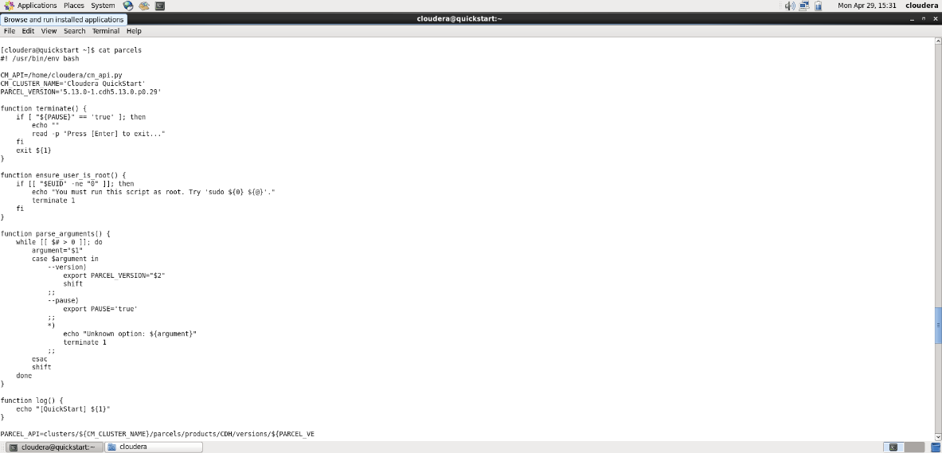

1. Cd: changes the current directory in Linux and can conveniently toggle between directories.

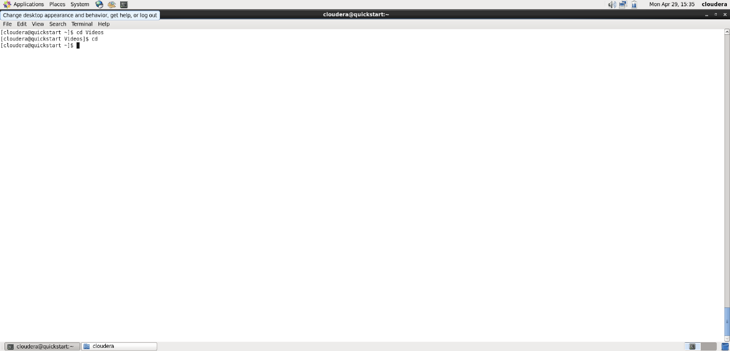

1. Cp: copies files and directories. Copies can be made simultaneously to another directory even if the copy is under a different name.

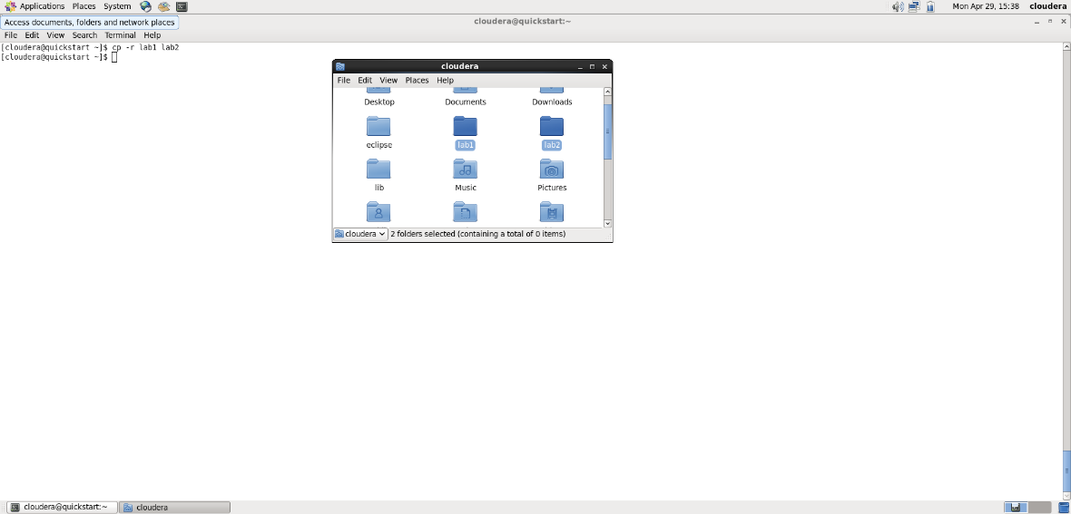

1. Find: searches the directory tree to locate particular groups of files that meet specified conditions, including -name, -type, -exec, -size, -mtime and -user.

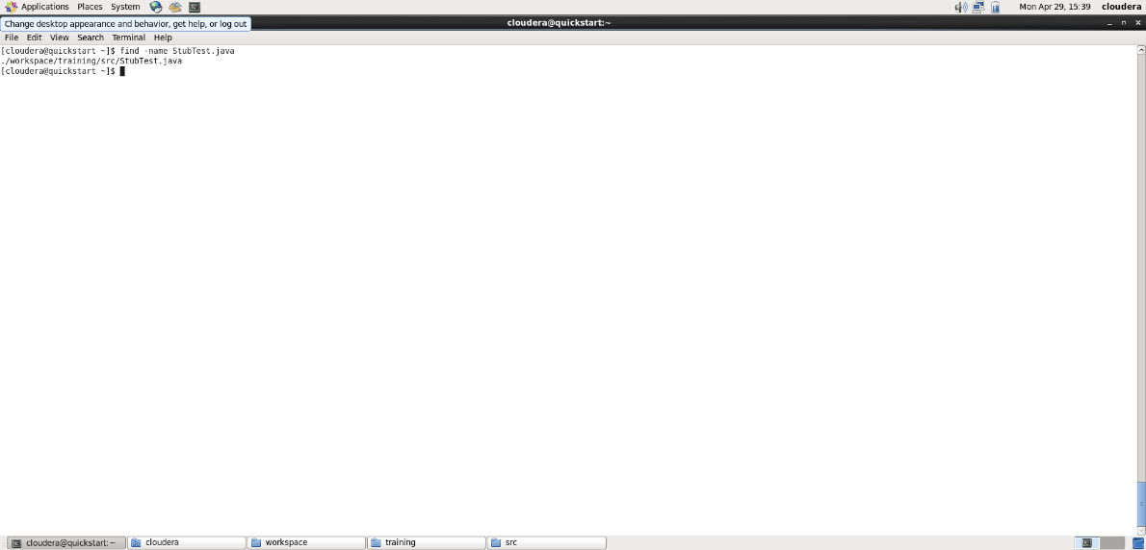

1. Mkdir: generates a new directory with a name path.

